Victorian Curriculum F–10 links:
Levels 5 and 6
History
Historical Knowledge
The Australian colonies
The nature of convict or colonial presence, including the factors that influenced changing patterns of development, how the environment changed, and aspects of the daily life of the inhabitants, including Aboriginal and Torres Strait Islander peoples
The effects of a significant development or event on a colony

Activity: Step back in time(Years 5 and 6)
  - From past to present—at the Western Treatment Plant
Students use an historical perspective to describe the events that led to the development of the Melbourne sewerage system and Western Treatment Plant.

Duration
Two-hour session
Activity steps
- Pose the following questions:
- What would Melbourne have been like before European settlement?
- What was life like growing up in the 1880s?
- What would people have done with their waste including their rubbish, recycling and sewage?
- Focus students’ thinking on housing, transport, food, clothing, streets and buildings, and how these may differ from today.
- Use digital resources to help students gain a sense of what it was like to live in Melbourne during these times. Useful resources include:
  - View the following resources in Scootle at <https://www.scootle.edu.au/ec/p/home>. Teachers can register for free with their school email address.
- R3347 Collins Street, Melbourne, 1889 (painting) The painting Collins Street, Melbourne, 1889 portrays a street filled with activity of the people of that era, the forms of transport used (tram, wagon and horseback) and the street paved with flagstones.
- R6401 'Your house and mine', 1954 - asset 12 (film clip) The film clip 'Your house and mine' provides a look at the backyard lanes and backyard toilets and is a reminder of how things would have been when ‘nightmen’ collected the nightsoil.
  - View clips of early Melbourne to discuss lifestyle and what it might have been like to live in Melbourne in the early 1900s:
Marvellous Melbourne: Queen City of the South, circa 1910, Australian Screen website, <http://aso.gov.au/titles/documentaries/marvellous-melbourne/>
  - View maps, images of the people, early works and information about the Board of Works at <http://www.cv.vic.gov.au/stories/built-environment/melbourne-and-smellbourne/>
  - The video ‘The urinal’ is an introduction to early Melbourne’s human waste problem and the events that lead to the design and building of the sewage system and Western Treatment Plant. See ‘The urinal’, <https://museumsvictoria.com.au/melbournemuseum/learning/school-programs-and-resources/dunny-detectives-excavating-little-lon-self-directed/dunny-detectives-back-at-school-activities/>
- Follow up the video with the Student worksheet: Melbourne to Smellbourne and how it cleaned up its act. Organise students to work in pairs, for example pairing up students with differing literacy levels, to read the texts and organise them into a chronological order of events using cues in the text.
- Lead discussion about the following questions:
- What ‘major problem’ did Melbourne have in the 1880s?
- What did the ‘nightman’ do?
- What is the Melbourne Metropolitan Board of Works? Why was it formed? What did it do?
- What would our life be like if we did not have a sewerage system?
- Students use the following sources from the Melbourne Water website to refine the sequence of events that they developed in pairs:
- History of sewerage <http://melbournewater.com.au/aboutus/historyandheritage/historyofsewerage/Pages/history-of-sewerage.aspx>
- Our history - a timeline <http://melbournewater.com.au/aboutus/historyandheritage/Pages/Our-history-a-timeline.aspx>
- History of the Western Treatment Plant <http://melbournewater.com.au/aboutus/historyandheritage/historyofsewerage/Pages/History-of-the-Western-Treatment-Plant.aspx>
- After finalising the sequence of events, each pair of students could create a book using the text as a basis and illustrate pages to support it.

Extension activities
How did the life of Aboriginal people differ from that of the Europeans who settled Melbourne?
Find out more about a waterborne disease such as typhoid and diphtheria.

Resources about the history of sewerage
Night Soil, Kingston Historical Website, <http://localhistory.kingston.vic.gov.au/htm/article/30.htm>

Student worksheet: Melbourne to Smellbourne
Cut out the text boxes. Put them in order to tell the story of Melbourne’s sewerage history.
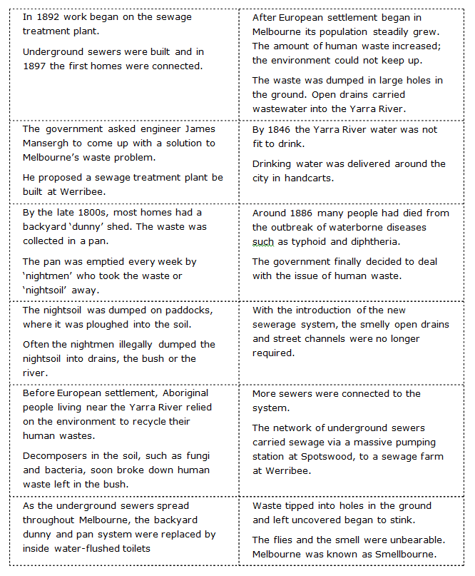

Victorian Curriculum and Assessment Authority (VCAA) <http://victoriancurriculum.vcaa.vic.edu.au/> Accessed 14 August 2016.

